Sending an Email to Your Instructor

The easiest way to send an email message to your instructor in your Blackboard course is to use Blackboard's built-in email tool. From inside your course, click on Tools in the menu. Scroll down and find Send Email.
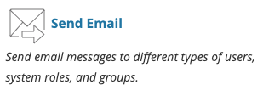
If you do not see the Send Email tool in your list, it is because your instructor prefers another contact method. Check your syllabus to find out their preferred method.

After clicking Send Email, scroll down and click on All Instructor Users.

Note: You should never use the All Users to send an email to the entire course.

Enter your email's subject and message.

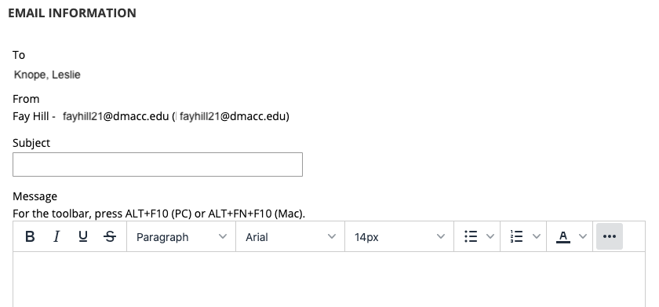

To attach a file to send to your instructor, click the Attach a file link and you will be walked through attaching the file.

When you are finished, click the Submit button.

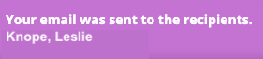
On the next screen, a purple box will display a confirmation that your email was sent.

You also will receive a copy of the email in your DMACC email inbox to confirm that the message was sent. Keep this copy for your records.

These emails will go directly to your instructor's DMACC email box. The expected response time is based on their communication policy outlined in the course syllabus. When your instructor responds, the response will go to your DMACC email address.

You should check your DMACC email at least once a day. DMACC email can be received on most Smartphone devices. Visit DMACC Tech Support Training Documents for instructions on setting up email on your mobile device.

If you wish to email one person, such as a classmate, in your course, you can accomplish this from the Send Email tool as well. Instead of selecting All Instructor Users from the list, click Select Users.

To select your recipient, click on their name in the left column to highlight it. Then use the arrow to move them to the right column. If you accidentally add the wrong recipient, highlight their name in the right column, and use the arrow to move them back to the left column.

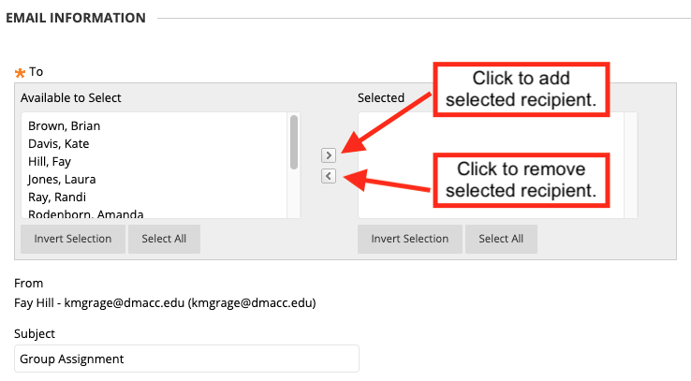

Complete the subject and message and submit as described above to send your email.

